1. **Background Investigation and Description**

Tik-Tok is prominent social media application that allow users to create, watch and share short clips on their mobile phones. The app holds consumer with its AI based scrolling where user can see all kind of videos on their feed. It has many different features like filter, music, dual screening which looks more engaging for all kind of users.

With its simple UX design, basic feature and colorful filters, music library, sounds, hashtag makes this application more attracting. Tik Tok has been launched in 75 different languages and over 150 different countries. The app has crossed nearly two billion downloads in March 2020. The annual revenue of Tik Tok is more than 58 million dollars as per the 2021 report.

Tik-Tok’s user base

* More than 70 percent user between age 14 to 26
* Over sixty percent are female
* Its user spends over 45 minutes a day
* About 96 million downloaders are from US
* It was second most downloaded app in US year 2020
* It is being opened eight times a day by any regular users
* It has more than a billion active users

1. **Problem Statement and Proposed Solution**

In this social media era Tik Tok has made a separate space for all kind of user with its 15 sec short clips feeds. People are spending most of their time scrolling Tik Tok. Application like this creates different environment for people which looks more demanding. With unique video creating features this app provides endless watching for users with exciting filters. But it requires constant development to keep running this application with upgrading features.

Although Tik Tok has many new features, but it could still develop more features like pinned videos, add videos to individual folders, sort feed as per the user interest, it could also change the scrolling style. In the solution to these problems, this case helps how to develop an application like Tik Tok which can deliver user friendly experience to the consumers and engage them with watching and creating different videos in this application.

1. **The main features of Tik Tok**

Tik-Tok includes some basic features which allow uses to follow each other, like and share videos. Every user can be able to change their profile and set notification as they want after joining.

**Video Uploading**

Tik-Tok allows user to upload their own videos on platform like any other social media application.

**Video Editing**

It allows users to trim, crop, and rotate videos as well as change playback speed of their videos. They can also record their own videos and do lip-sync with the music library.

**Filters and Effects**

The video editor has many filters and effects like beauty filters as well as variety of stickers and animations for adding their content.

**Social Sharing**

It allows user to share their videos to other social media platforms like Facebook, Instagram. Users can also link their profile to other platforms.

**Likes and Comments**

Tik Tok’s like function works same as it works for Instagram, with heart serving as likes. Also, there is a dedicated tab for viewing their liked videos.

**Duets**

Duet is one of the famous features of TikTok which allow users to do lip-sync with their favorite music with another person on side-by-side screen. It can be a friend, a completely random person or even with a celebrity.

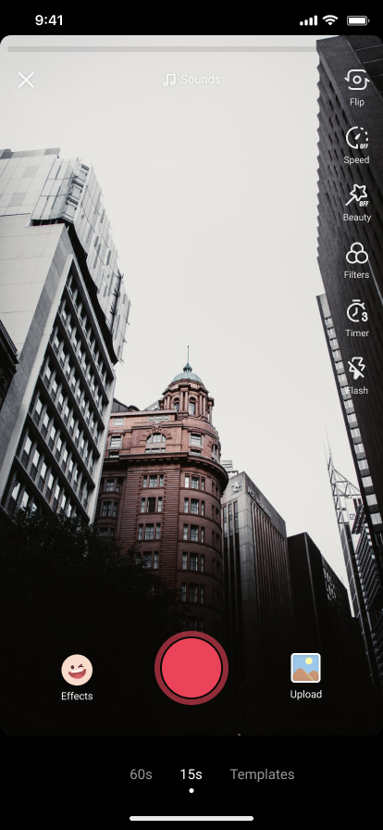

1. **User Stories**

* As a content creator, I want to have an "add to favorites" option So that I can store videos in an organized way that can be easy to browse for me.
* As a UX designer, I want smooth scrolling for Tik Tok videos as Instagram. So, it can give a rich experience to users.
* As a user, I want to have pinned video feature in Tik Tok so that I don't have to scroll down too much to find a particular video as Tik Tok has a tiled chronological view in a user profile.
* As a daily user, I want an option to categorize my interest that will appear on my feed so that I don't have to watch random feeds based on my previous search.

**Backlogs**

* As a user, I want to add my favorite videos in individual folders so that it would be easy to browse again. (User request)
* As a developer, I want to change the scrolling speed for Tik Tok (development activity)
* Add pinned feature to the app so that users can find their favorite videos conveniently. (User request)
* Create new feature to add interest for main feeds. (feature)

**Sprints**

* Add and develop the "individual folder" as per the user request (13 days)
* backend developing for Tik Tok application (14 days)
* Design and implement pinned feature in the app (10 days)
* Add and develop the "add interest" feature as per the user request (13 days)

1. **System requirements**

* Tik Tok can run on Android devices with 4.2 or higher and in IOS version 9.3 or higher
* Require stable internet connection

**User requirements**

* Create a Profile
* Need to add personal details
* Can connect with other social media
* Can browse videos from the phone
* Can like, share videos, and follow other profiles
* Push notifications

**Interface requirements**

1. **Prototypes**

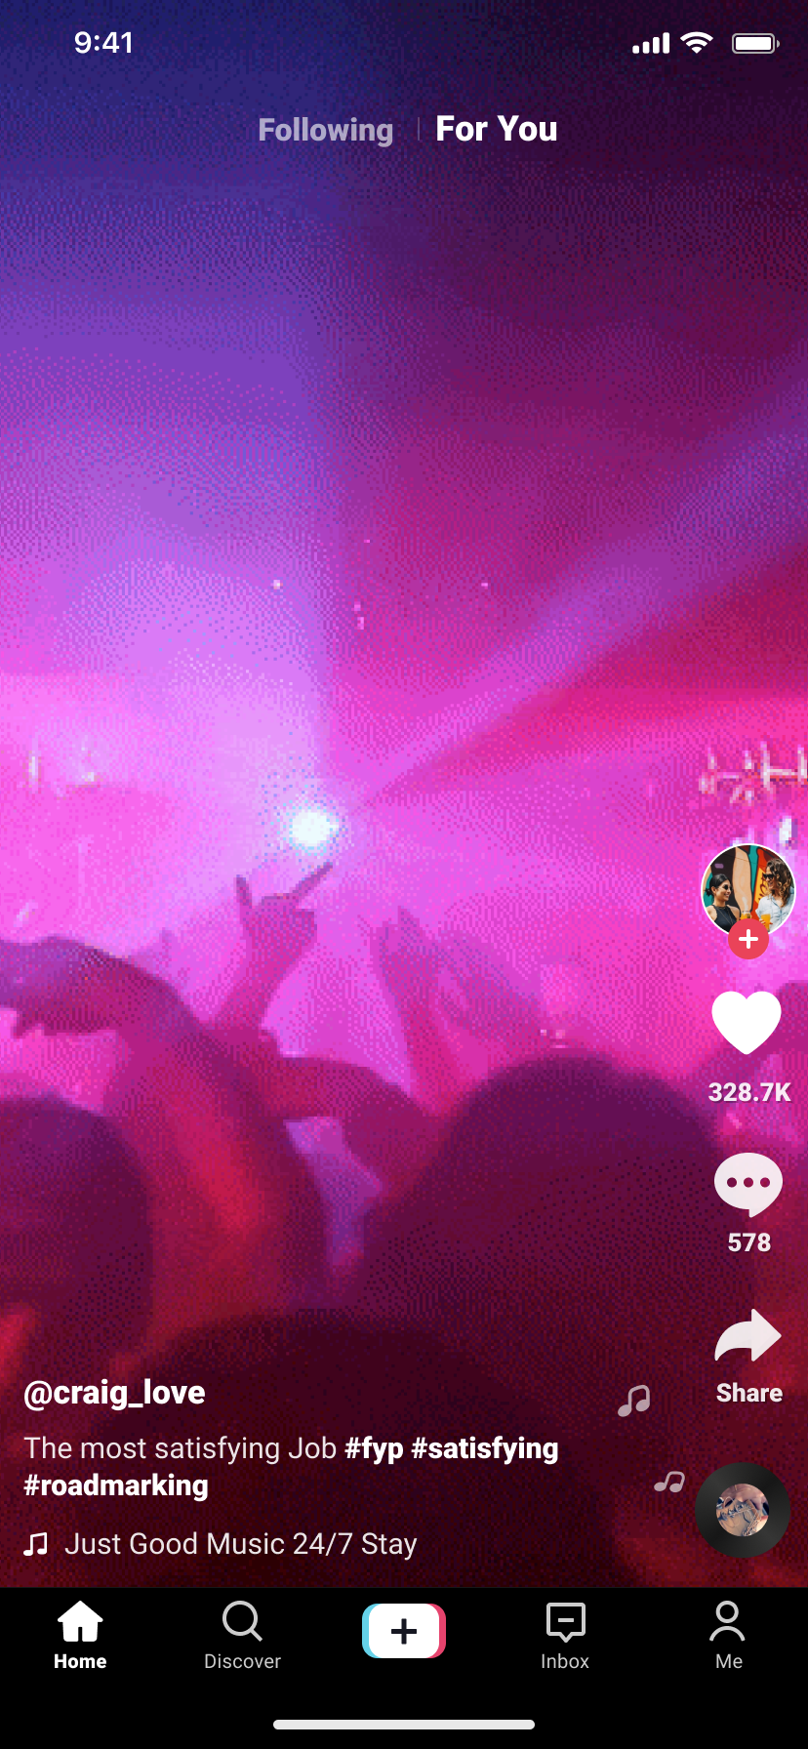

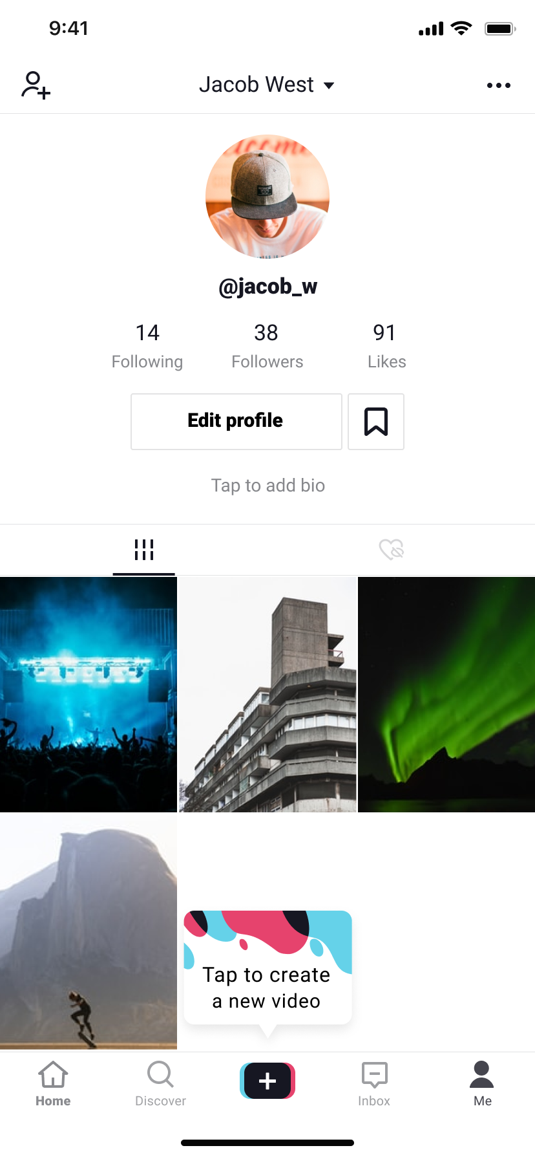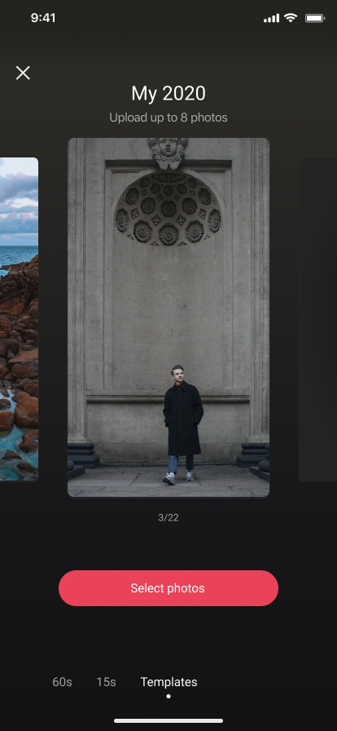

1. **Prioritizing backlogs and sprint**

By prioritizing backlogs and sprint the most important feature is to develop “add to individual folders”. As per the user request by developing this feature user will be able to store the videos into the individual folder. They can add any videos to any different folders they named after.

